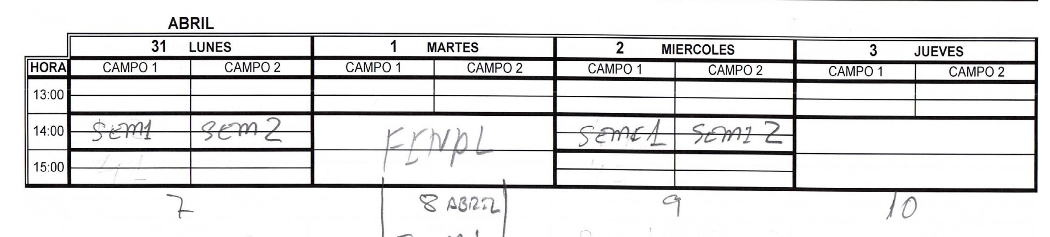

|  |  |  |  |  |  |  |  |  |
| --- | --- | --- | --- | --- | --- | --- | --- | --- |
|  | **ABRIL** | |  |  |  |  |  |  |
|  | **7 LUNES** | | **8 MARTES** | | **9 MIERCOLES** | | **10 JUEVES** | |
| **HORA** | CAMPO 1 | CAMPO 2 | CAMPO 1 | CAMPO 2 | CAMPO 1 | CAMPO 2 | CAMPO 1 | CAMPO 2 |
| 13:00 |  |  |  |  |  |  |  |  |
|  |  |  |  |  |  |  |  |
| 14:00 |  |  | **FINAL FUTBOL 7 14:00 HORAS** | |  |  |  | |
|  |  |  |  |
| 15:00 |  |  |  | |  |  |  | |
|  |  |  |  |